# Material [1] [2] ([R134-a](https://www.freon.com/en/-/media/files/freon/freon-134a-push-bulletin.pdf?rev=299648e517aa4efda7674b2db8de0f3b#:~:text=Freon%E2%84%A2%20134a%20is%20nonflammable,where%20these%20properties%20are%20critical.)) [saturation Temperature = 247.05 K](https://www.engineeringtoolbox.com/r134a-properties-d_1682.html.)

|  |  |  |  |
| --- | --- | --- | --- |
| Property | R134-a Liquid | R134-a Vapor | Unit |
| Density |  | 5.25 |  |
| Dynamic Viscosity | 0.000249 | 1.13e-05 | kg/ (m s) |
| Molecular weight | 102.03 | 102.03 |  |
| Specific heat | 1420 | 880 |  |
| Standard state enthalpy | 3.916e+08 | -2.845e+08 |  |
| Thermal conductivity | 0.081 | 0.013 |  |

## E = 0.8

### Geometry

Major Axis a = 11.90625 mm

Minor Axis b = 9.525 mm

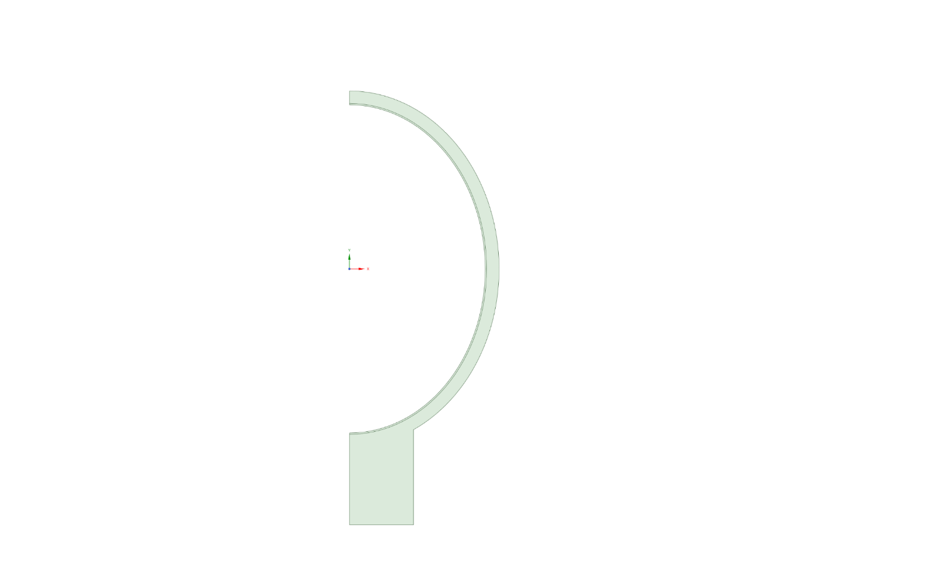

### Temperature

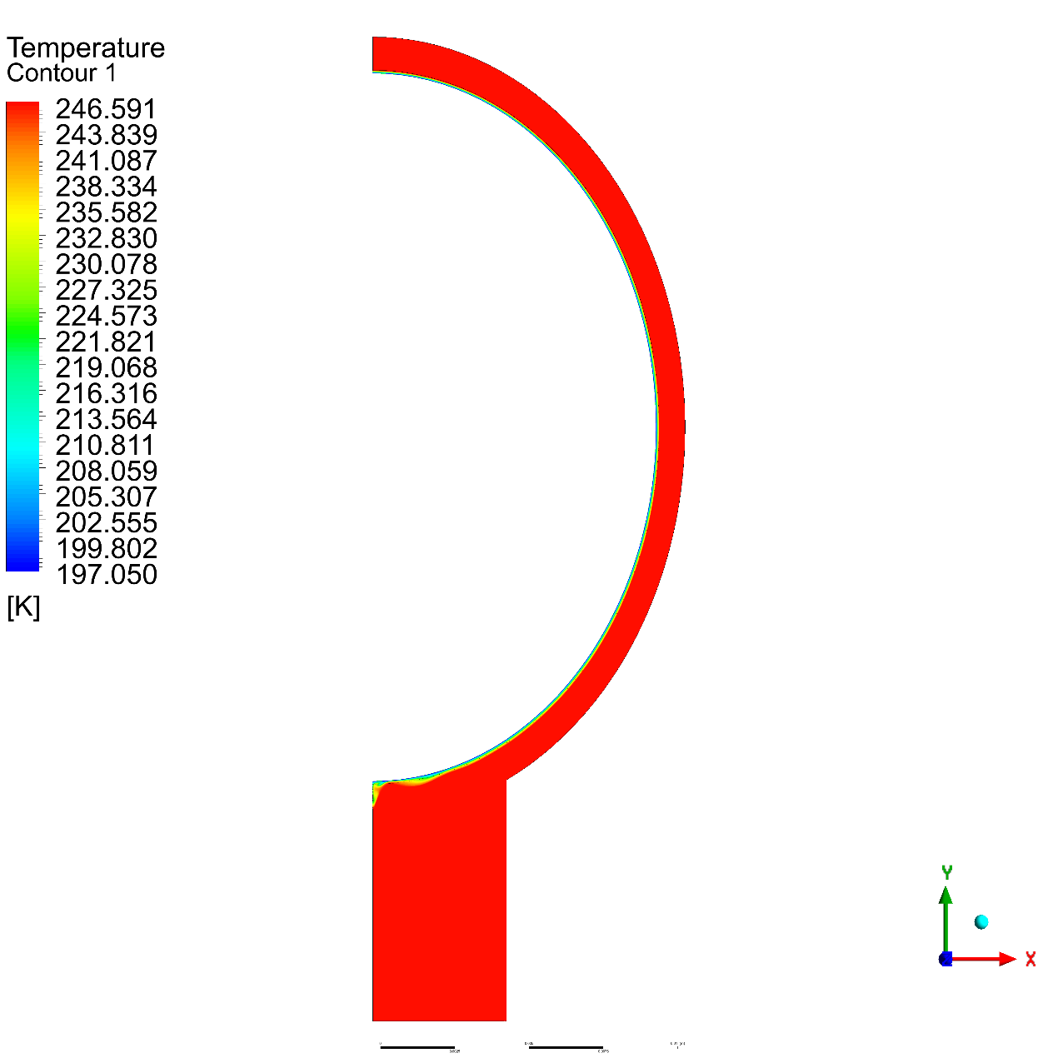

### Volume Fraction

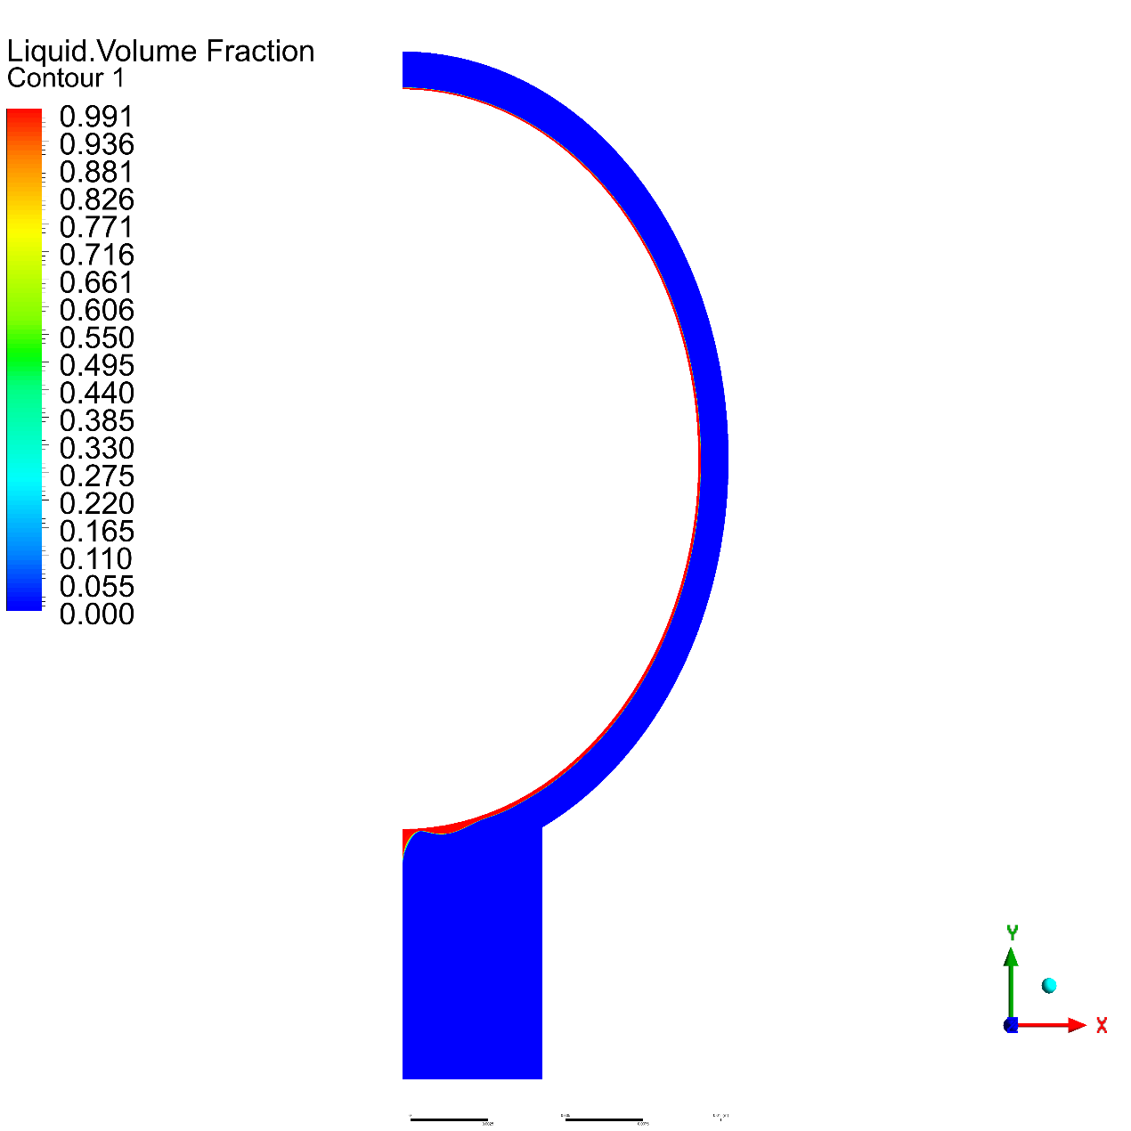

## E = 0.6

### Geometry

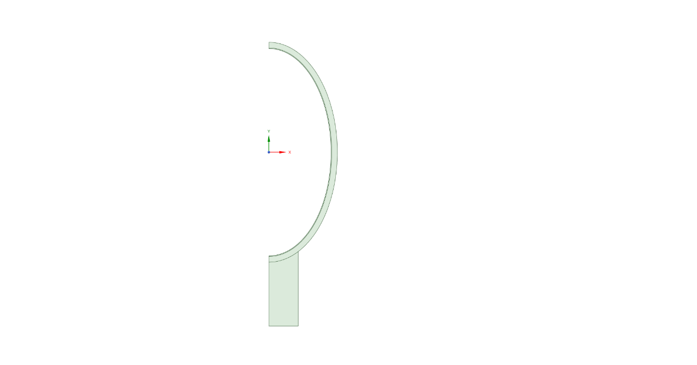

Major Axis a = 15.857 mm

Minor Axis b = 9.525 mm

### Temperature

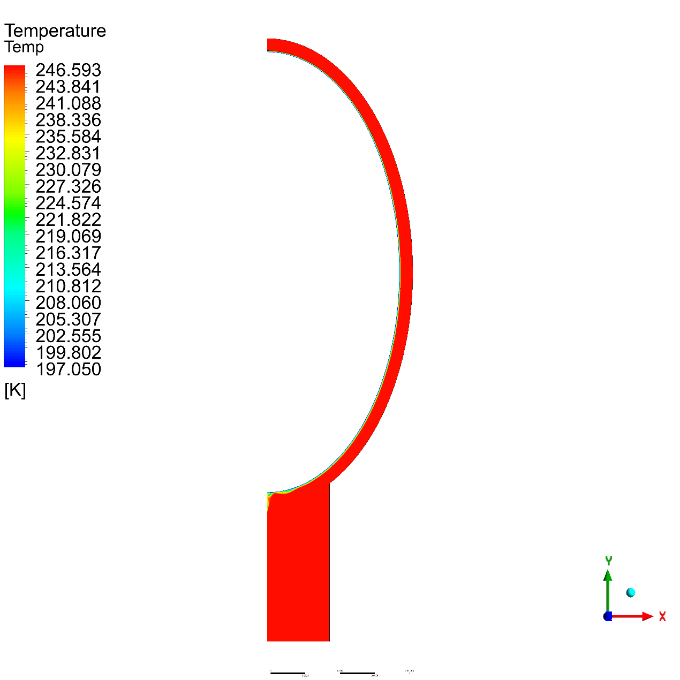

### Volume Fraction

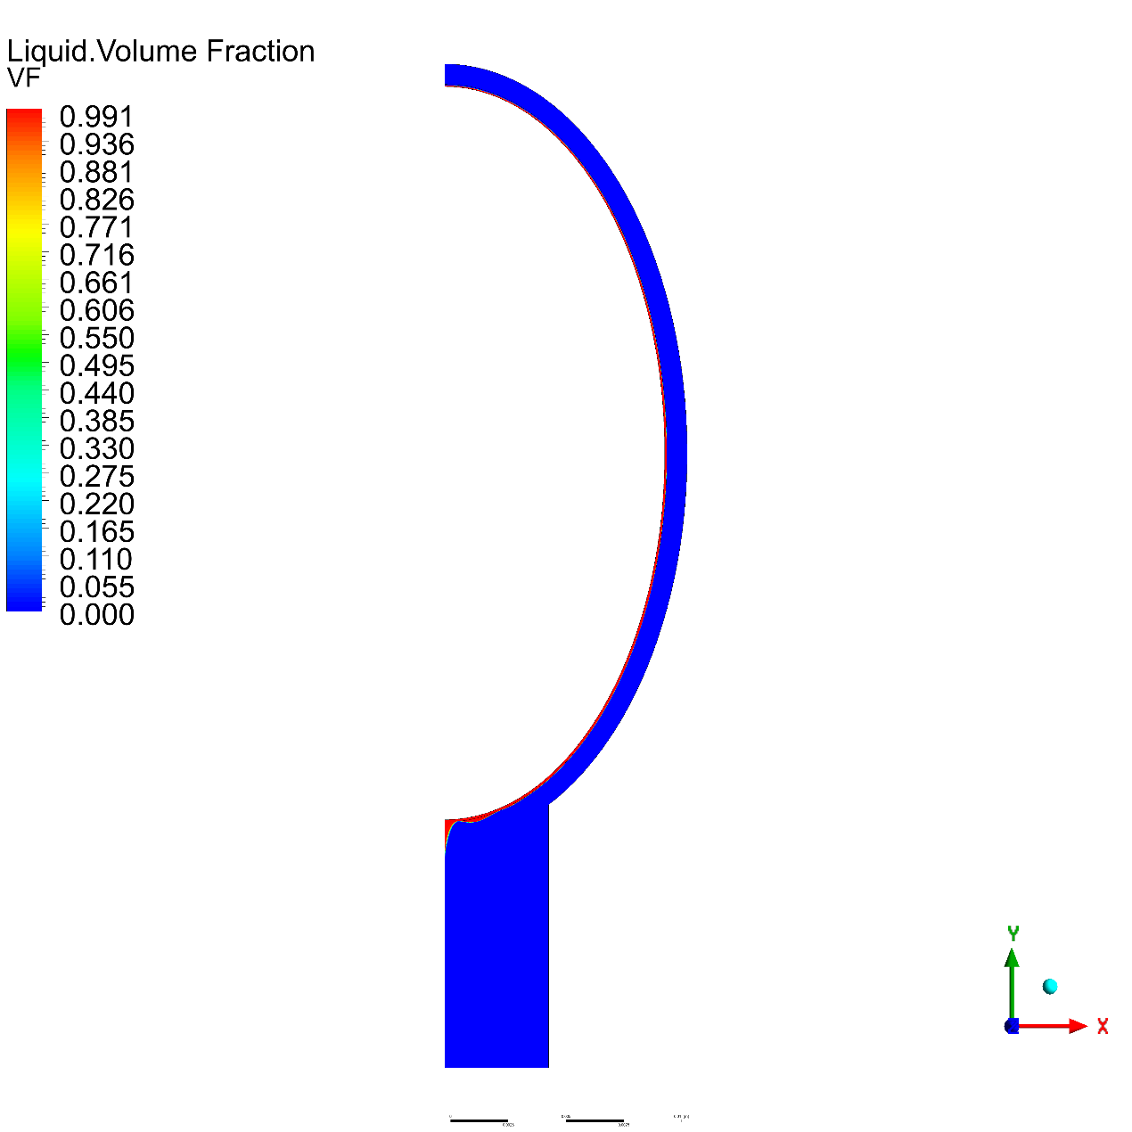

## E = 0.4

### Geometry

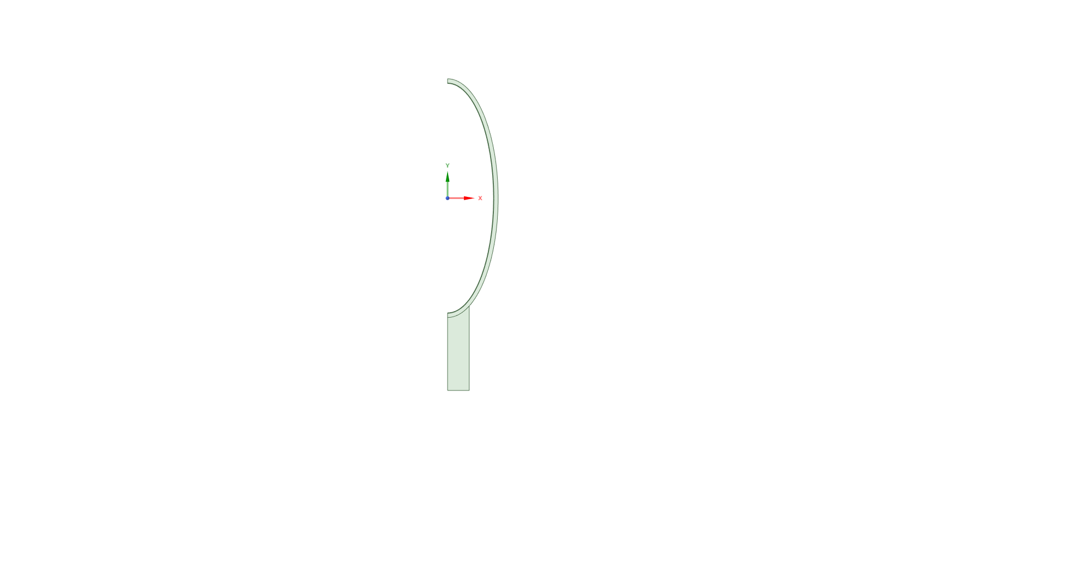

Major Axis a = 23.8125 mm

Minor Axis b = 9.525 mm

### Temperature

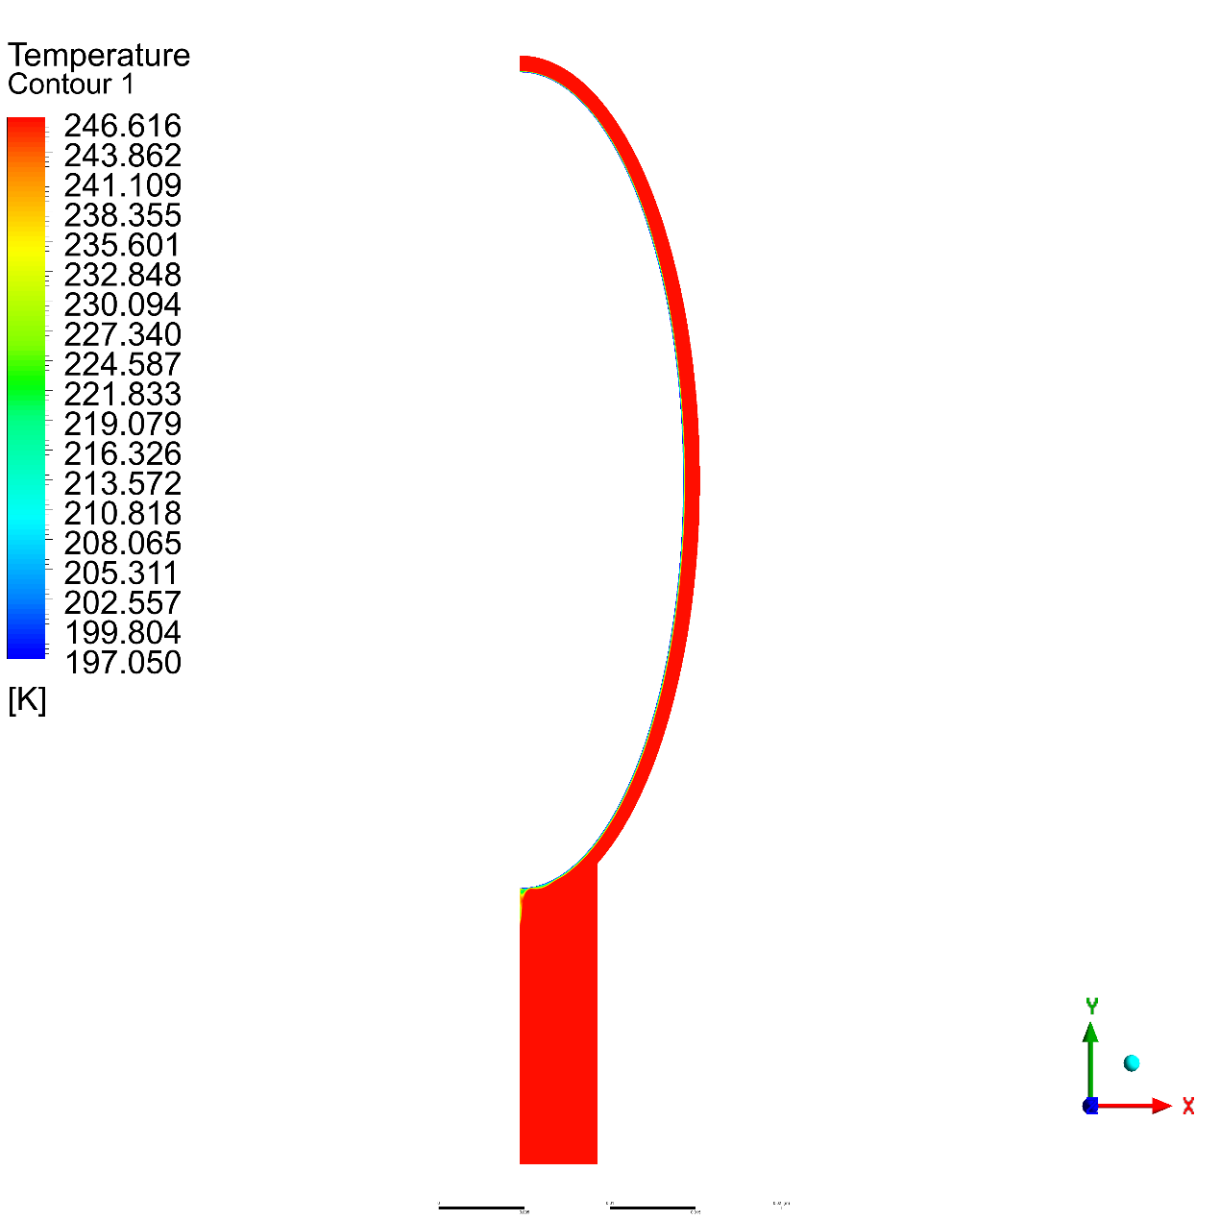

### Volume Fraction

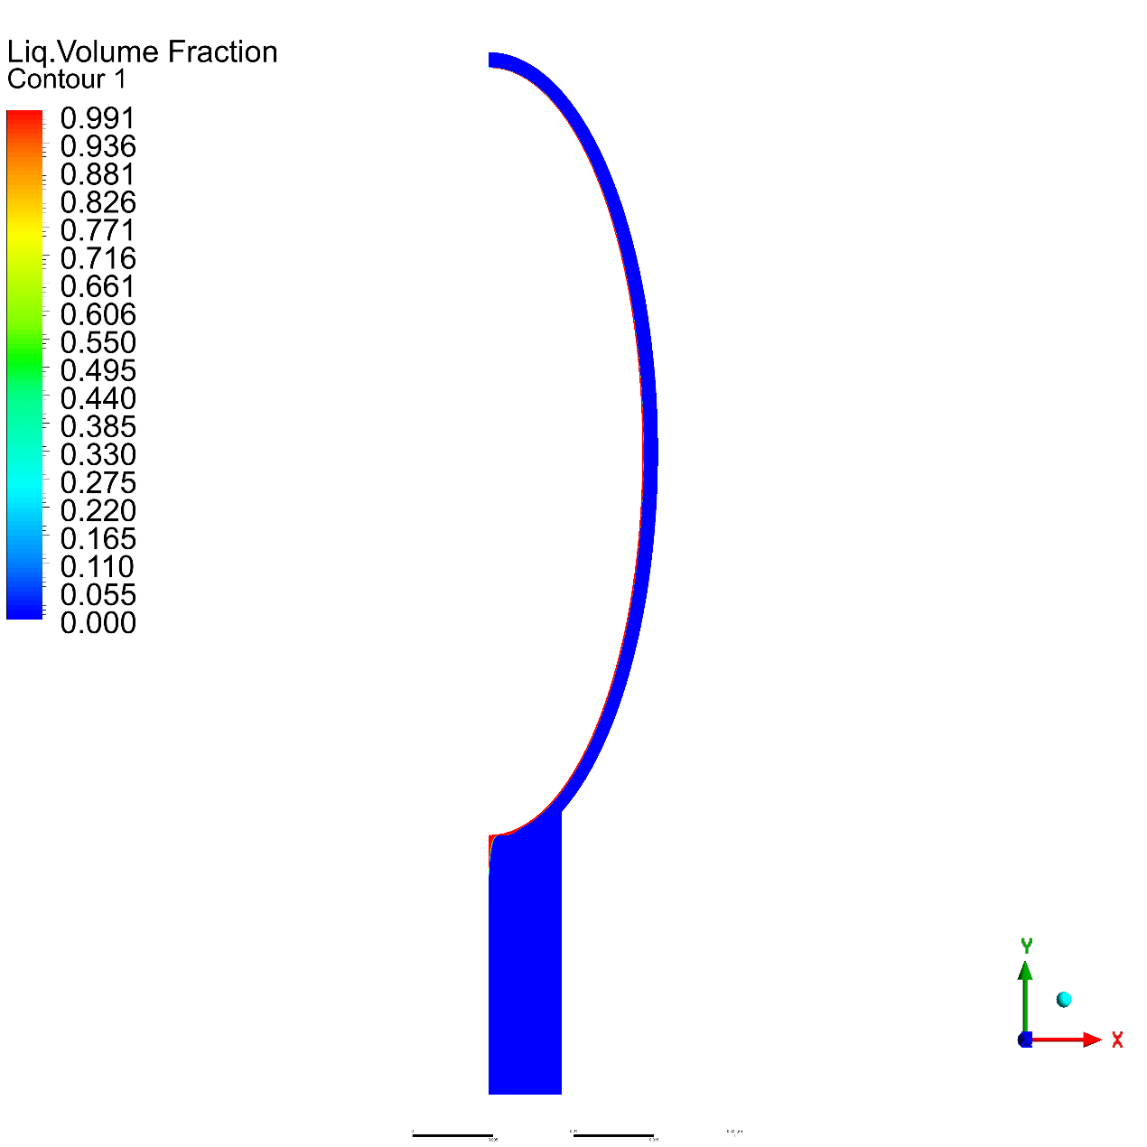

## E = 0.2

### Geometry

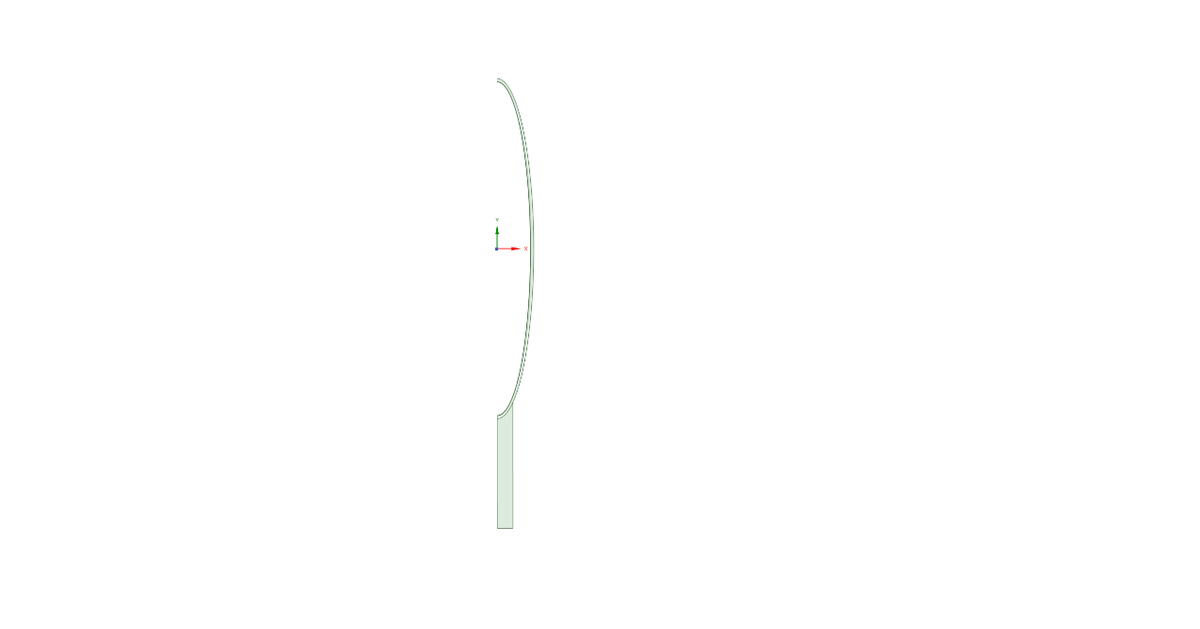

Major Axis a = 47.625 mm

Minor Axis b = 9.525 mm

### Temperature

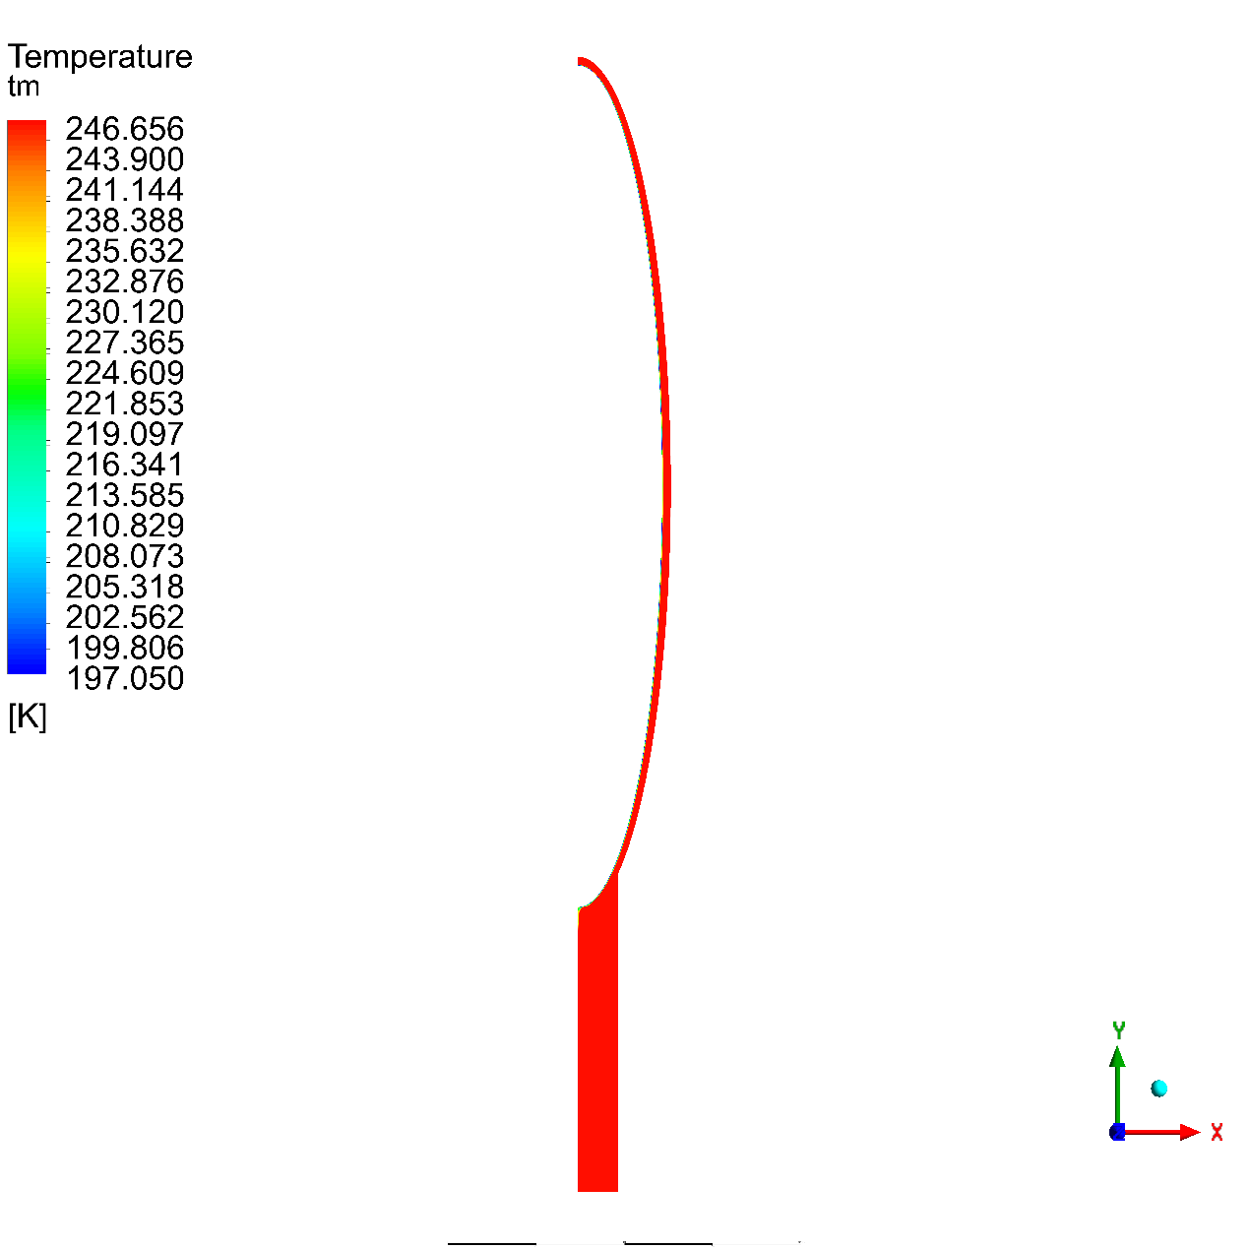

### Volume Fraction

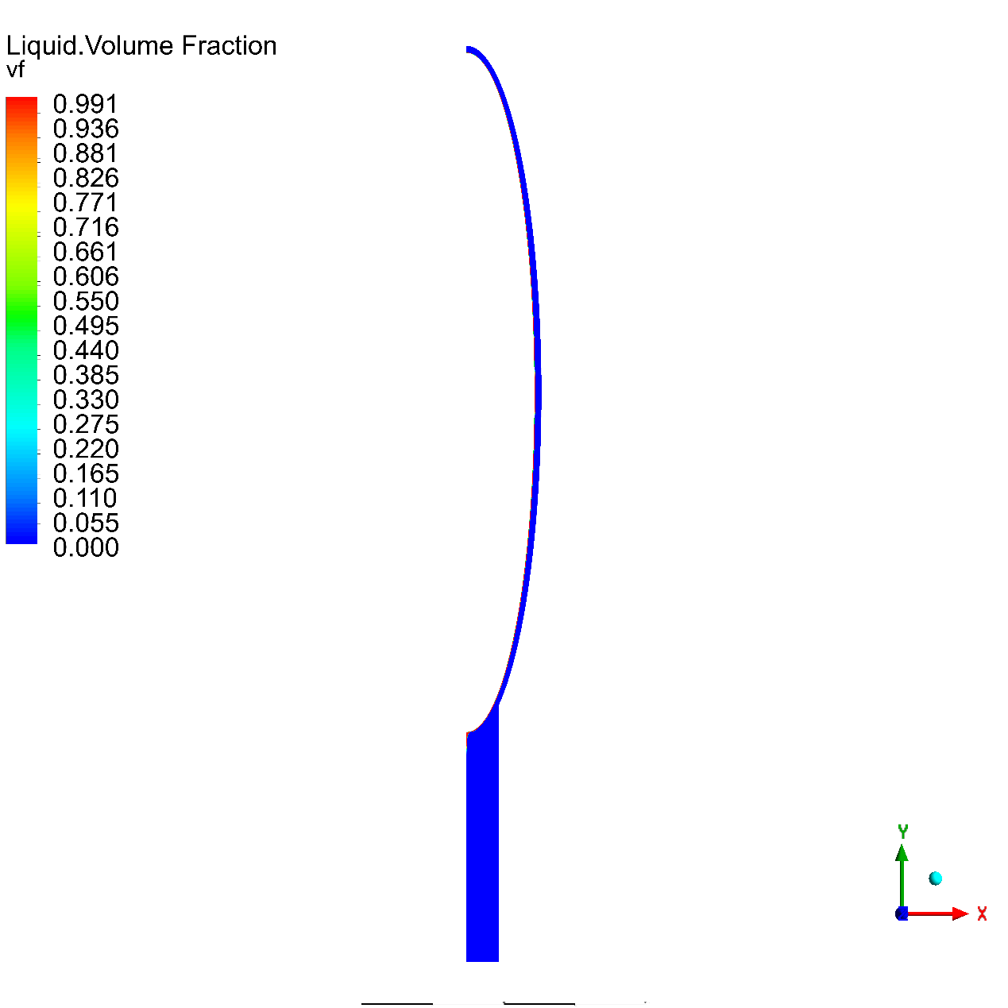

## Phase Fraction Charts





## Temperature Charts



Wall Heat Flux



# References

|  |  |
| --- | --- |
| [1] | Freon™. [Online]. Available: https://www.freon.com/en/-/media/files/freon/freon-134a-push-bulletin.pdf?rev=299648e517aa4efda7674b2db8de0f3b. |
| [2] | engineeringtoolbox. [Online]. Available: https://www.engineeringtoolbox.com/r134a-properties-d_1682.html. |